 |  |  |  |  |  | WARRANTY CLAIM FORM  FORWARD THE ORIGINAL COPY TO:  Accuride Corporation  Warranty Department  warrantyadmin@accuridecorp.com  1-800-869-2275; Ext. 1
DATE:
PLEASE PRINT CLEARLY AND LEGIBLY – ILLEGIBLE CLAIMS WILL BE RETURNED FOR CORRECTION.
This warranty claim will not be processed without complete information being filled in and sent to Accuride.

No claim shall be granted if the product and/or components have been subjected to abuse, misuse, misapplication, alteration, or improper installation/maintenance. See product brochures for complete Warranty Statement. Customer or distributor must retain part(s) until notified of disposition by Accuride or until given a Returned Goods Authorization (RGA) for return analysis. Do not return parts without an RGA.
PRODUCT INFORMATION
 |  |  | ITEM ONE |  |  |  | ITEM TWO |  |  |  | ITEM THREE |  |  |  |  |  |  |  |  | ITEM FOUR
PART
NUMBER
DATE CODE
See Attached Sheets
DATE OF LAST
WHEEL END SERVICE
COMPONENT
MILEAGE
QUANTITY

CONCERN:
DESCRIBE THE CONCERN BELOW. BE SPECIFIC ABOUT THE LOCATION OF THE CONCERN.
FLEET OR OWNER/OPERATOR
NAME OF OWNER |  |  |  |  |  |  |  |  | ADDRESS
CITY |  |  |  |  |  |  |  |  | STATE |  |  |  | ZIP CODE |  |  |  | PHONE NUMBER
Please indicate which Axle the product came off of: Steer Drive Tag Pusher Lift Trailer

VOCATION – Please mark an X next to the one that best describes the application.
 | Cement / Concrete Delivery |  |  |  |  |  |  |  | City Service Vehicle |  |  |  |  |  |  |  |  | Car / Livestock Hauler
 | Construction / Dump Truck |  |  |  |  |  |  |  | Emergency Service Vehicle |  |  |  |  |  |  |  |  | Motorhome / RV / Coach
 | Fire Truck |  |  |  |  |  |  |  | Food or Beverage Delivery |  |  |  |  |  |  |  |  | Tractor Tanker
 | Heavy Haul (Gravel, Mining, etc.) |  |  |  |  |  |  |  | Pick-Up and Delivery |  |  |  |  |  |  |  |  | Tractor Trailer – End Dump
 | Logging |  |  |  |  |  |  |  | School Bus |  |  |  |  |  |  |  |  | Tractor Trailer – Flatbed
 | Mobile Crane |  |  |  |  |  |  |  | Sightseeing / City Bus |  |  |  |  |  |  |  |  | Tractor Trailer – Line Haul
 | Refuse |  |  |  |  |  |  |  | State Vehicle |  |  |  |  |  |  |  |  | Tractor Trailer – Refrigerated
 | Snow Plow |  |  |  |  |  |  |  | Utilities Truck |  |  |  |  |  |  |  |  | Other:
ACCURIDE DISTRIBUTOR OR RECOGNIZED TRUCK AND/OR TRAILER DEALERSHIP
COMPLETE ACCURIDE DISTRIBUTOR OR OE DEALERSHIP INFORMATION AND ADDRESS IS NECESSARY FOR CREDIT DESIGNATION OR REPLACEMENT
DEALERSHIP FOR |  |  |  |  |  |  |  |  |  | OE DEALER CODE |  |  |  |  |  |  |  |  | DISTRIBUTOR OR DEALER CLAIM #
AUTHORIZED DISTRIBUTOR OR ORIGINAL EQUIPMENT MANUFACTURER’S NAME |  |  |  |  |  |  |  |  |  | PHONE NUMBER
ADDRESS |  |  |  |  |  |  |  |  |  | CITY |  |  |  |  |  | STATE |  |  |  |  | ZIP CODE
SIGNATURE |  |  |  |  | PRINT NAME |  |  |  |  | EMAIL ADDRESS

Accuride Steel Wheel Identification

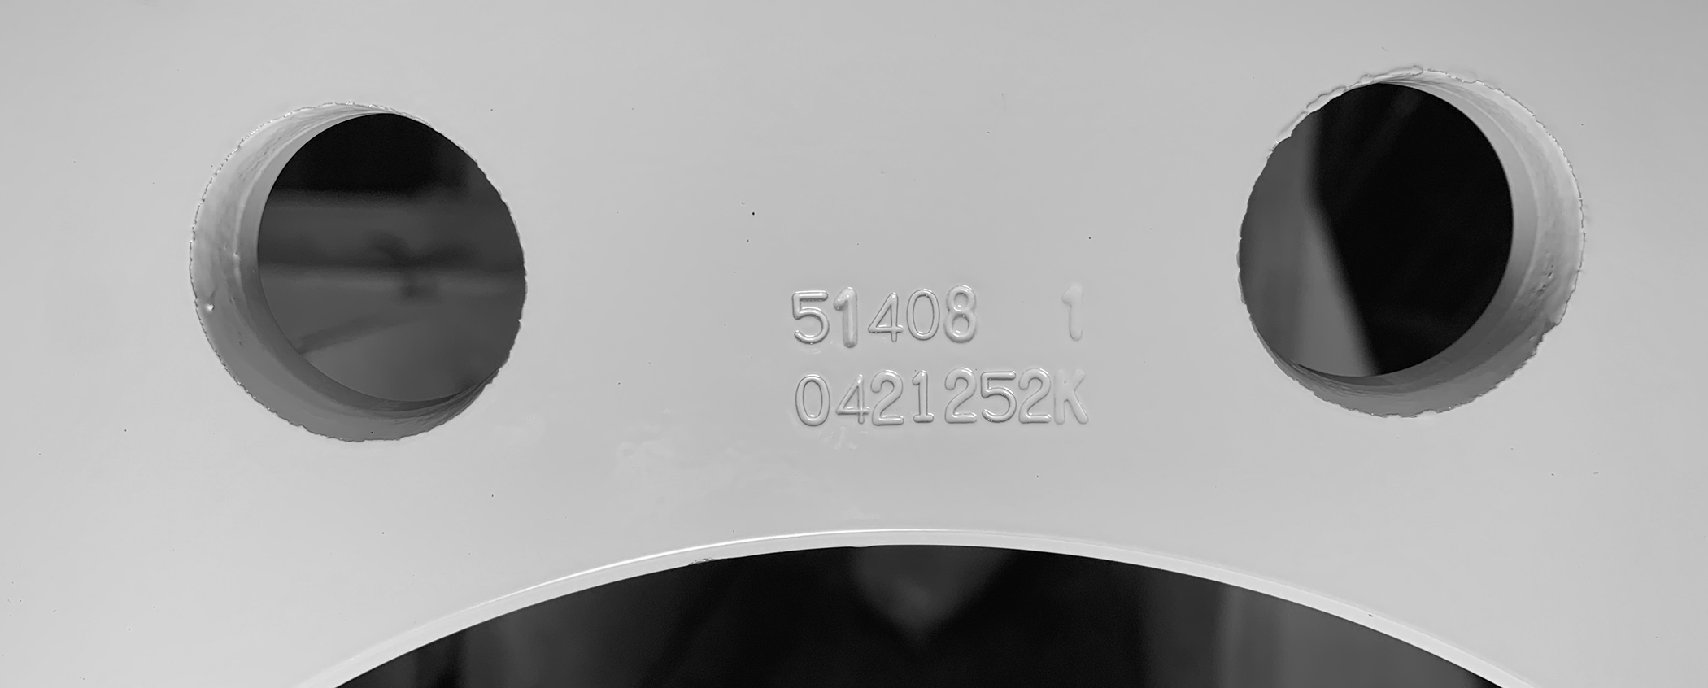

Part #
51408

Date Code
04/21/25 Plant K

Accuride Aluminum Wheel Identification
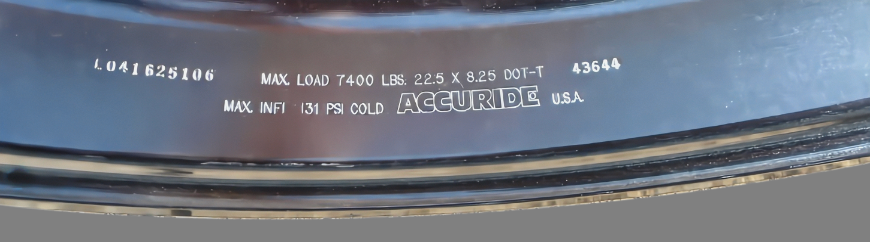
Part #
43644
Date Code
04/16/25 Plant L

