 |  |  |  |  |  | WARRANTY CLAIM FORM  FORWARD THE ORIGINAL COPY TO:  Accuride Corporation  Warranty Department  warrantyadmin@accuridecorp.com  1-800-869-2275; Ext. 1 |  |  |  |  |  |  |  |  |  |  |  |  | 
DATE:
PLEASE PRINT CLEARLY AND LEGIBLY – ILLEGIBLE CLAIMS WILL BE RETURNED FOR CORRECTION.
This warranty claim will not be processed without complete information being filled in and sent to Accuride.

No claim shall be granted if the product and/or components have been subjected to abuse, misuse, misapplication, alteration, or improper installation/maintenance. See product brochures for complete Warranty Statement. Customer or distributor must retain part(s) until notified of disposition by Accuride or until given a Returned Goods Authorization (RGA) for return analysis. Do not return parts without an RGA.
PRODUCT INFORMATION
 |  |  | ITEM ONE |  |  |  | ITEM TWO |  |  |  | ITEM THREE |  |  |  |  |  |  |  |  | ITEM FOUR
PART
NUMBER
DATE CODE
See Attached Sheets
DATE OF LAST
WHEEL END SERVICE
COMPONENT
MILEAGE
QUANTITY

CONCERN:
DESCRIBE THE CONCERN BELOW. BE SPECIFIC ABOUT THE LOCATION OF THE CONCERN.
FLEET OR OWNER/OPERATOR
NAME OF OWNER |  |  |  |  |  |  |  |  | ADDRESS
CITY |  |  |  |  |  |  |  |  | STATE |  |  |  | ZIP CODE |  |  |  | PHONE NUMBER
Please indicate which Axle the product came off of: Steer Drive Tag Pusher Lift Trailer

VOCATION – Please mark an X next to the one that best describes the application.
 | Cement / Concrete Delivery |  |  |  |  |  |  |  | City Service Vehicle |  |  |  |  |  |  |  |  | Car / Livestock Hauler
 | Construction / Dump Truck |  |  |  |  |  |  |  | Emergency Service Vehicle |  |  |  |  |  |  |  |  | Motorhome / RV / Coach
 | Fire Truck |  |  |  |  |  |  |  | Food or Beverage Delivery |  |  |  |  |  |  |  |  | Tractor Tanker
 | Heavy Haul (Gravel, Mining, etc.) |  |  |  |  |  |  |  | Pick-Up and Delivery |  |  |  |  |  |  |  |  | Tractor Trailer – End Dump
 | Logging |  |  |  |  |  |  |  | School Bus |  |  |  |  |  |  |  |  | Tractor Trailer – Flatbed
 | Mobile Crane |  |  |  |  |  |  |  | Sightseeing / City Bus |  |  |  |  |  |  |  |  | Tractor Trailer – Line Haul
 | Refuse |  |  |  |  |  |  |  | State Vehicle |  |  |  |  |  |  |  |  | Tractor Trailer – Refrigerated
 | Snow Plow |  |  |  |  |  |  |  | Utilities Truck |  |  |  |  |  |  |  |  | Other:
ACCURIDE DISTRIBUTOR OR RECOGNIZED TRUCK AND/OR TRAILER DEALERSHIP
COMPLETE ACCURIDE DISTRIBUTOR OR OE DEALERSHIP INFORMATION AND ADDRESS IS NECESSARY FOR CREDIT DESIGNATION OR REPLACEMENT
DEALERSHIP FOR |  |  |  |  |  |  |  |  |  | OE DEALER CODE |  |  |  |  |  |  |  |  | DISTRIBUTOR OR DEALER CLAIM #
AUTHORIZED DISTRIBUTOR OR ORIGINAL EQUIPMENT MANUFACTURER’S NAME |  |  |  |  |  |  |  |  |  | PHONE NUMBER
ADDRESS |  |  |  |  |  |  |  |  |  | CITY |  |  |  |  |  | STATE |  |  |  |  | ZIP CODE
SIGNATURE |  |  |  |  | PRINT NAME |  |  |  |  | EMAIL ADDRESS
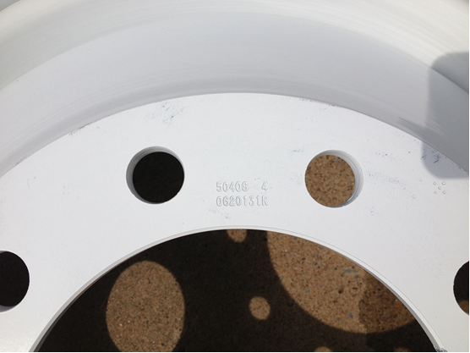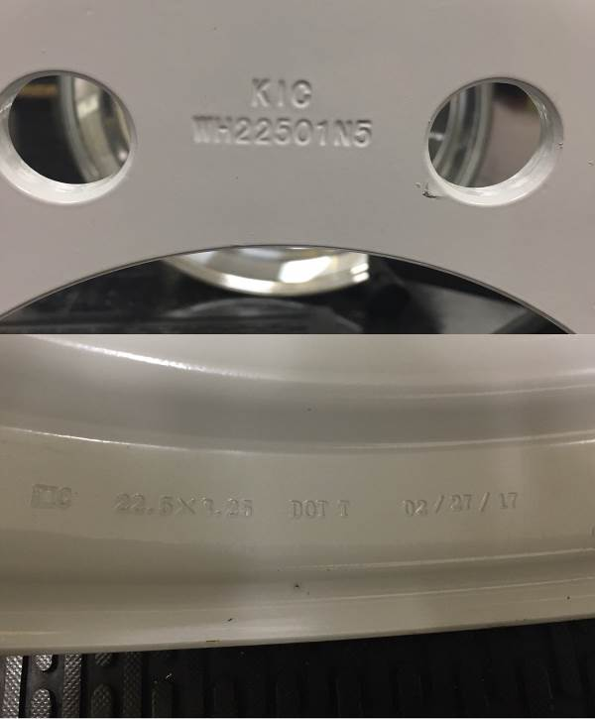
Part #
50408
Date Code
06/20/13 Plant K
Part #
WH22501N5
Date Code
2/27/17

Accuride Steel Wheel Identification KIC Steel Wheel Identification

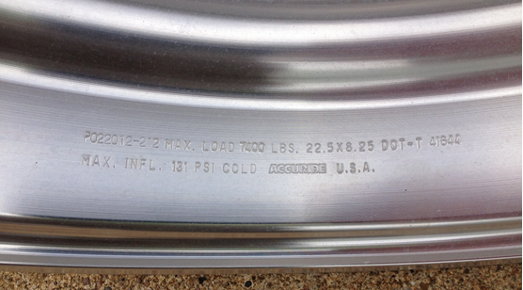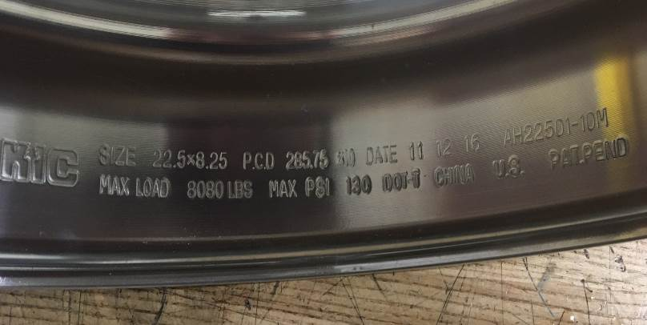
Part #
41644
Date Code
02/20/12 Plant P
Date Code
11/12/16
Part #
AH22501-10M

Accuride Aluminum Wheel Identification KIC Aluminum Wheel Identification

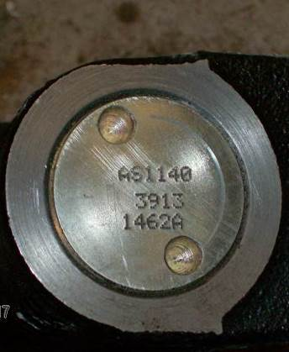
Part #
AS1140
Date Code 3913
Serial #1462A
Type II

Gunite Slack Adjuster Identification

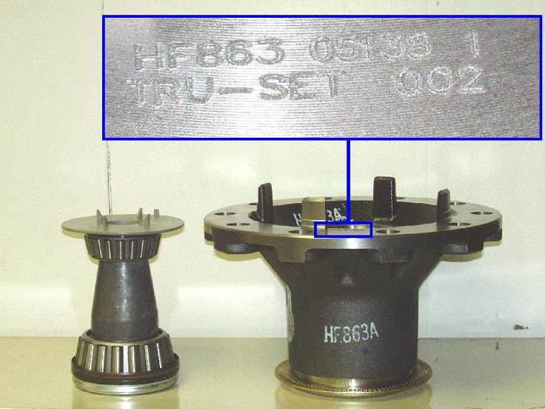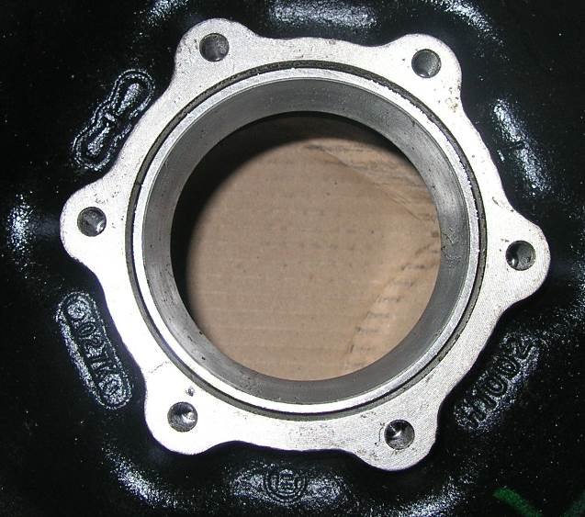
Part #
HF863
Date Code
05/13/08 Shift 1
Hub ID
SN# Tru-Set 002
Cast Part #
H1002
Casting Date
027K (01/27/07)

Gunite Disc Wheel Hub (Machined) Identification Gunite Disc Wheel Hub (Cast) Identification

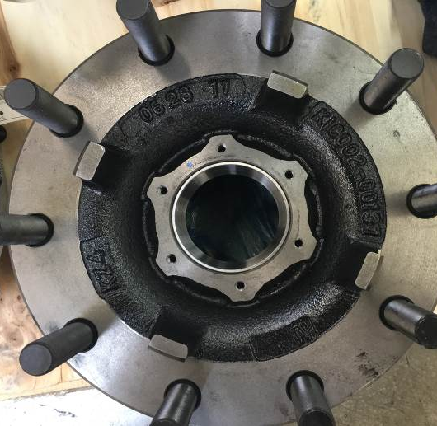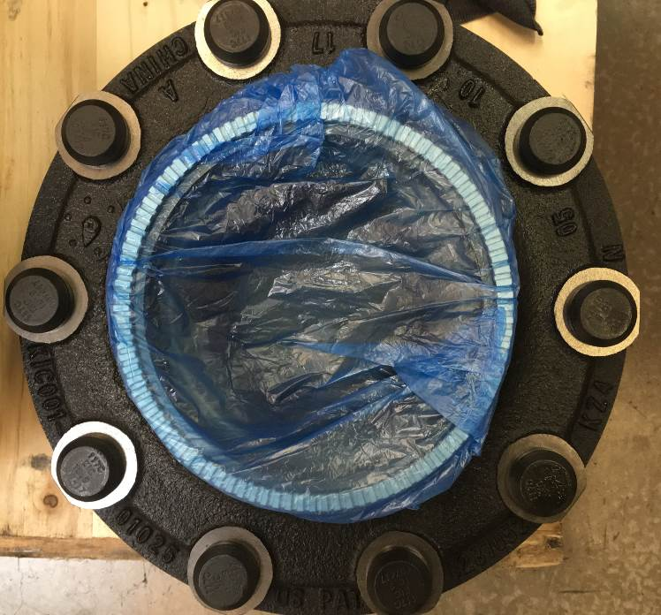
Casting Date
05/10/2017
Foundry Code
KZ4
Part #
1025
Part #
00137
Date Code
6/28/17
Foundry Code
KZ4
KIC Front Disc Wheel Hub (Identification) KIC Disc Wheel Hub (Cast) 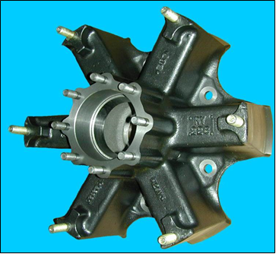 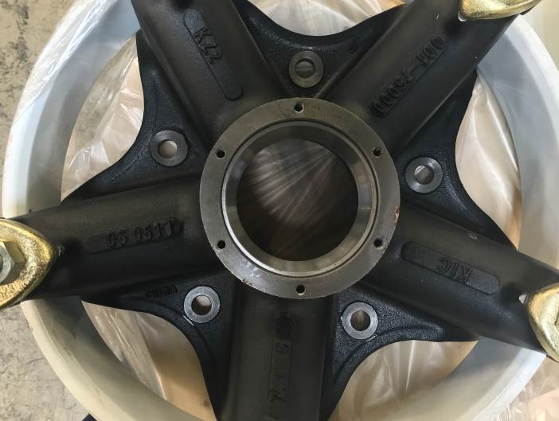
Part #
RY226
Cast Date Code
Day (22) Heat Run (02)
Cast Date Code
29V (Dec 2009 Shift 2)
Date Code
6/5/17
Part #
001-7500
Foundry Code
KZ2
Gunite Spoke Wheel Identification KIC Spoke Wheel Identification
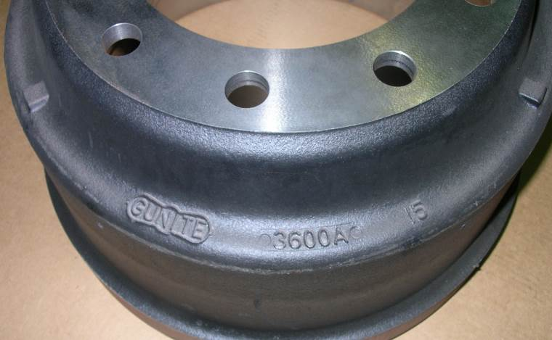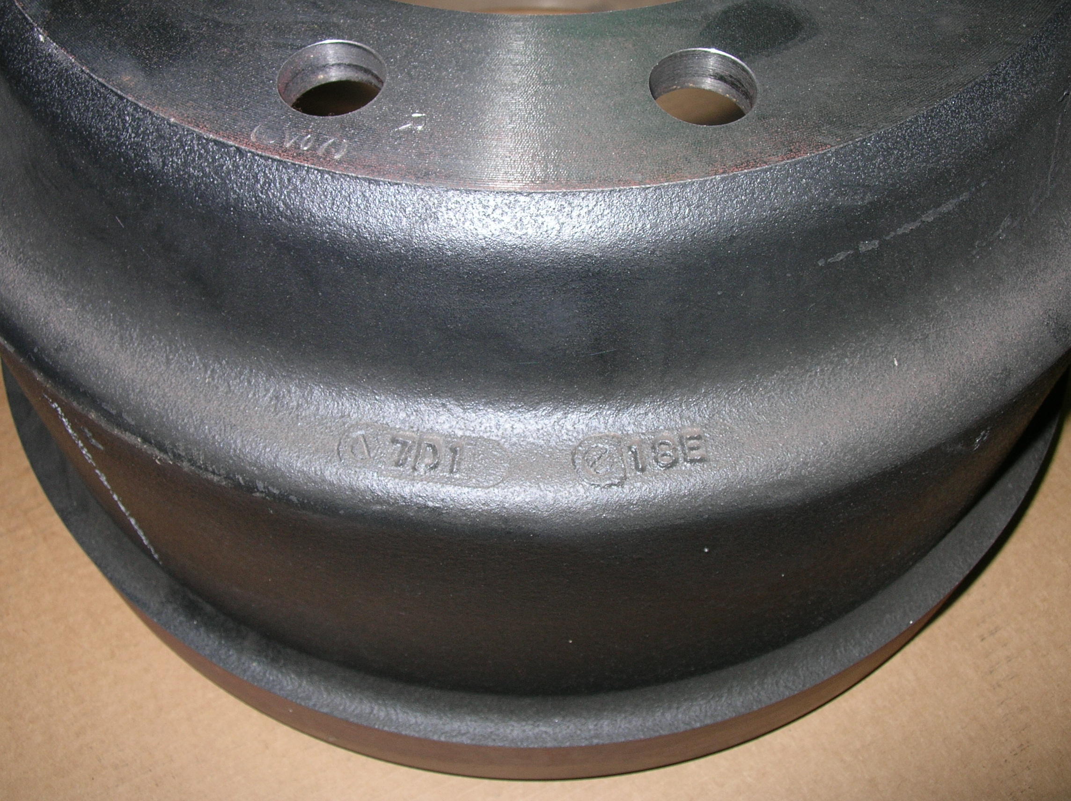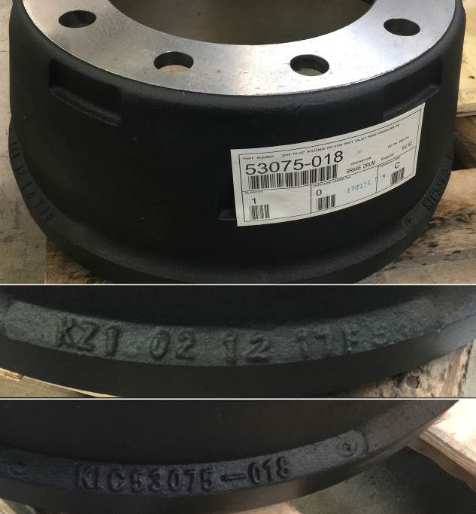
Date Code (Opposite Side from Part Number)
Year, Month, Shift (7, D, 1)
Day, Run (18, E)

Part #
3600A

Part #
3600A

Part #
53075-018

Year, Month, Shift (7, D, 1)
Casting Code and Date
KZ1 02 12 17

Gunite Brand Drum Identification KIC Brand Drum Identification 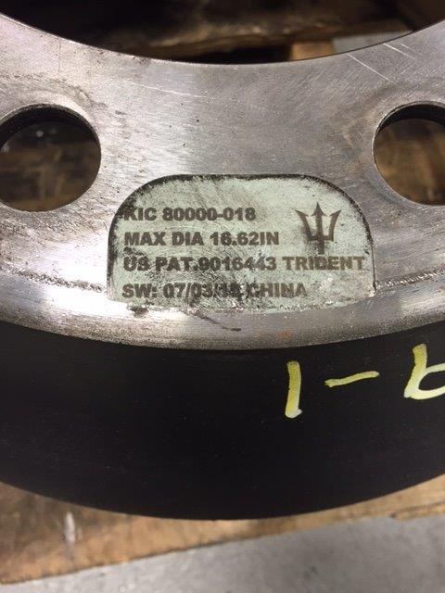 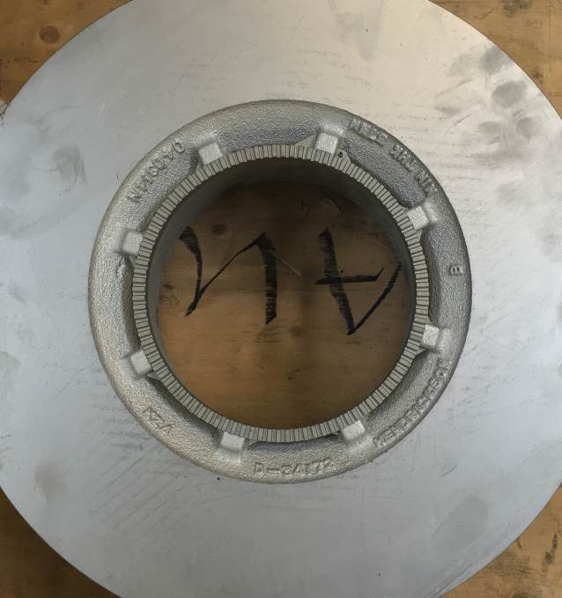
Foundry Code
KZA
Part #
D-34172
Date Code
04/03/14
Date Code
07/03/18
Part #
80000-018

KIC Trident Brand Drum Identification KIC Rotor Identification
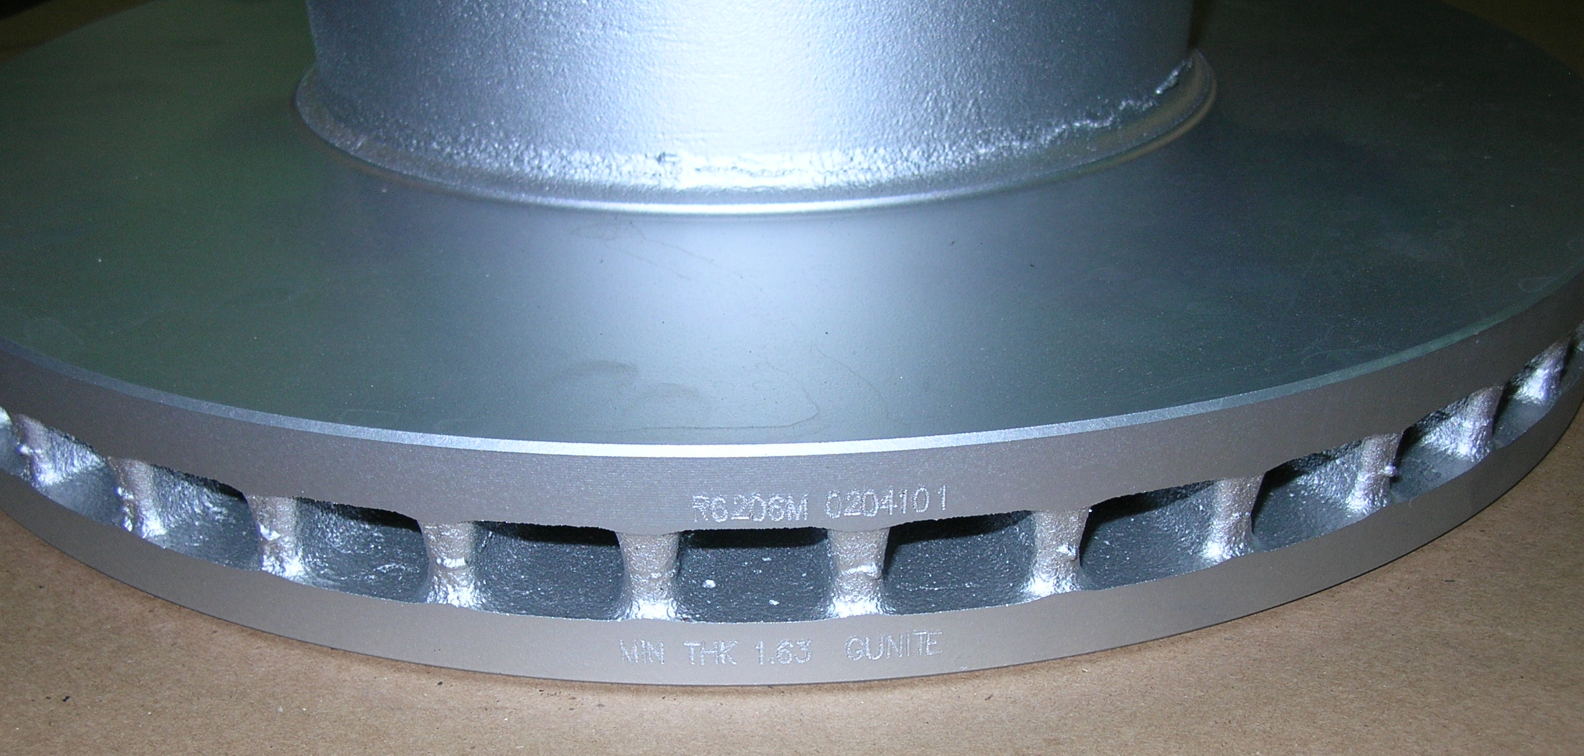
Part #
R6206M
Date Code
02/04/10 Shift 01
Gunite Rotor Identification

