 | Product/Process Change Notification |  |  |  |  | 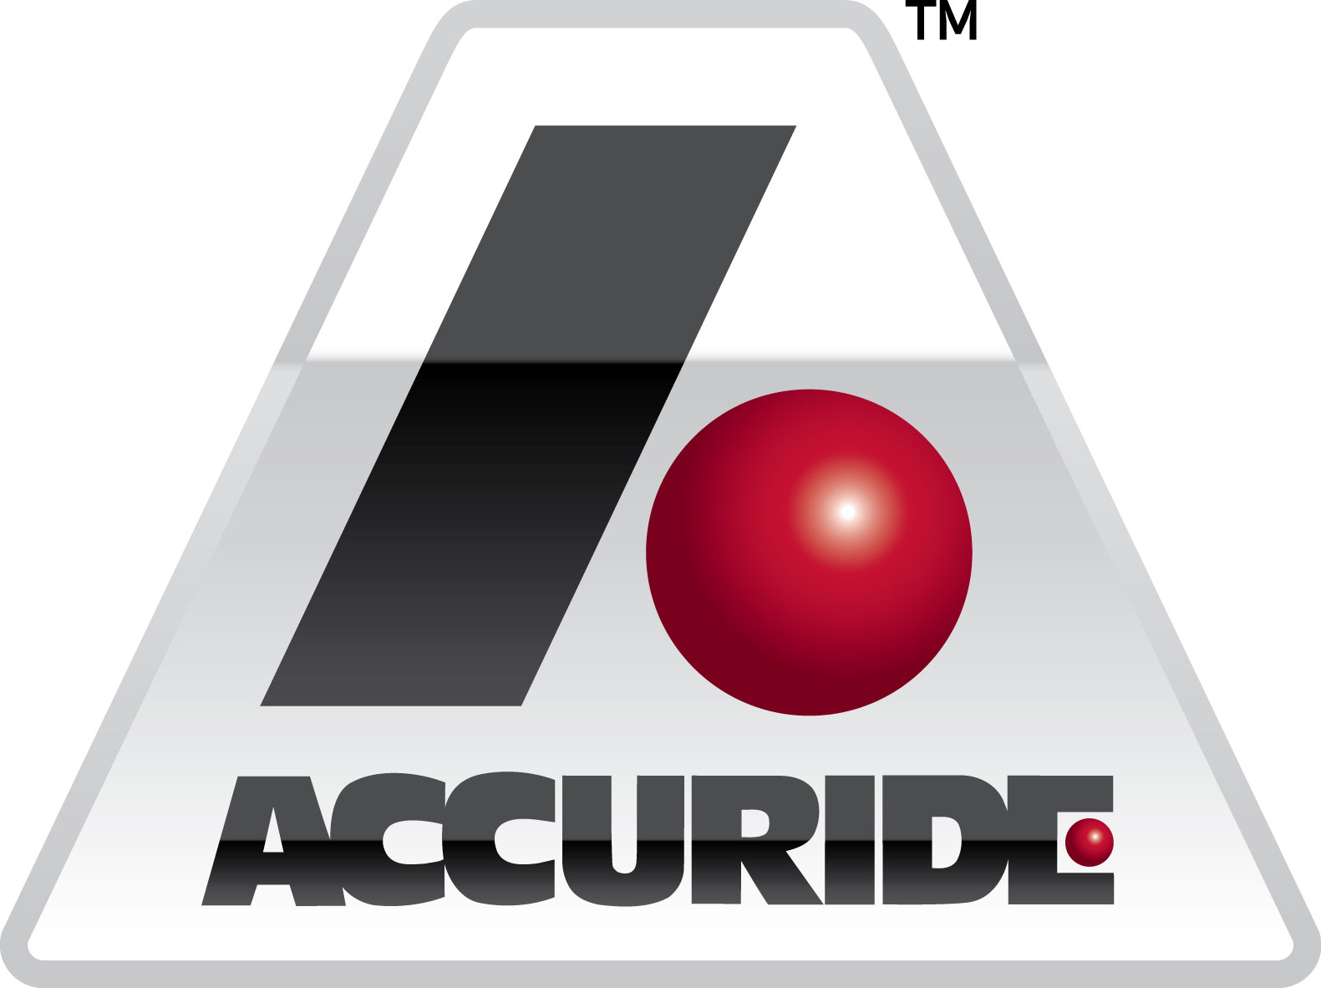
Complete this form and email to Buyer and/or Quality Engineer/Manager whenever customer notification is required by the PPAP manual in Table 3.1 of AIAG PPAP Manual 4th edition. Accuride Corporation business unit will respond back with an acknowledgment and may request additional change clarification or PPAP submission requirements. File name should be saved as Supplier Name + Change Notification Number.
* To: |  |  |  |  | Customer:
* Supplier |  | * Part Name |  |  | *Part Number |  | *Rev Level.
* Change Notification Number (Brand + Part Number + date mm/dd/yy) |  |  | Supplier Code No. |  | P.O. Number |  | Date (mm/dd/yy)

* Design Responsibility Customer Organization

*1. 0 REASON FOR CHANGE PER TABLE 3.1 of PPAP MANUAL
Use of other construction or material than was used in the previously approved part or product |  |  |  | Product and process changes related to components of the production product manufactured internally or manufactured by suppliers
Tooling: New or modified tools (except) perishable tools), dies, molds, patterns, etc. including additional or replacement tooling. |  |  |  | Change in test/inspection method-new technique (no effect on acceptance criteria)
Production following upgrade or rearrangement of existing tooling or equipment |  |  |  | Bulk Materials: New source of raw material from new or existing supplier.
Production from tooling and equipment transferred to a different plant site or from an additional plant site. |  |  |  | Bulk Materials: Change in product appearance attributes
Change of supplier for parts, non-equivalent materials, or services (e.g., heat treat, plating) |  |  |  | Change in Part Processing as result of 8-D Corrective action
Product produced after the tooling has been inactive for volume production for twelve months or more. |  |  |  | Customer Engineering Change
* 2.0 EXPECTED PPAP COMPLETION/SUBMISSION DATE:
* 3.0 PROPOSED PPAP SUBMISSION LEVEL (Check one)
Level 1 - Warrant only (and for designated appearance items, an Appearance Approval Report) submitted to the customer.
Level 2 - Warrant with product samples and limited supporting data submitted to customer.
Level 3 - Warrant with product samples and complete supporting data submitted to customer.
Level 4 - Warrant and other requirements as defined by customer.
Level 5 - Warrant with product samples and complete supporting data reviewed at supplier's manufacturing location.

* 4.0 PROPOSED PPAP SUBMISSION REQUIREMENTS
Dimensional Measurements Material and Functional Tests Results & Certification Capability Studies & Special Characteristic Summary List.
Updated Control Plans & FMEA Updated Process Flow Diagram Mold / Cavity Samples or Sectioned Samples Gauge R&R
Other Customer Specific Requirements (Specify):
* 5.0 SUPPLIER EXPLANATION / COMMENTS:
* Requestor Information:
Name Title Phone No. Email
* 6.0 ACCURIDE CORPORATION REVIEW:
COMMENTS:

Expected Time Required for PPAP Approval:
Quality Engineer: Date:
* 7.0 ACCURIDE CORPORATION CUSTOMER QUALITY ENGINEER REVIEW: PLEASE INPUT IF CUSTOMER SPECIFIC REQUIREMENT BEYOND NORMAL PPAP
COMMENTS:

Application Engineering Requirement if there are any:
Expected Time Required for Customer to Approve:
* Customer Quality Engineer: Date:
* MANDATORY FIELDS

